**Comprehensive School**

**“Padre Cesare Albisetti” - Terno d’Isola**

**The KINDERGARTEN**

**“Giuseppe Bravi” - Terno d’Isola**

**presents itself.**



Hey!

We are the children attending the Kindergarten of Terno d’Isola.

We will give you some useful information to understand how our school works.

AIMS AND FEATURES

The Kindergarten wants to ensure the full development of the personality of each child, at the educational level, despite the different paths and the variety of solutions.

It aims to promote the development of children’s identity, autonomy, competence, and to pave their way into citizenship (national indications for the curriculum of 4 September 2012).

BEGIN THE SCHOLASTIC YEAR WITH THE GRADUAL RECEPTION

It is important that, during the first week of attendance, the school is open only for the morning shift (8.30 -13.30) for all students: the presence of both teachers during the opening hours fosters a “soft” integration, giving the chance to focus more on children and on their needs. It also allows the use of an approach that reassures, distracts, and interests them more and which can get them acquainted with the environment and with people in a more peaceful atmosphere.

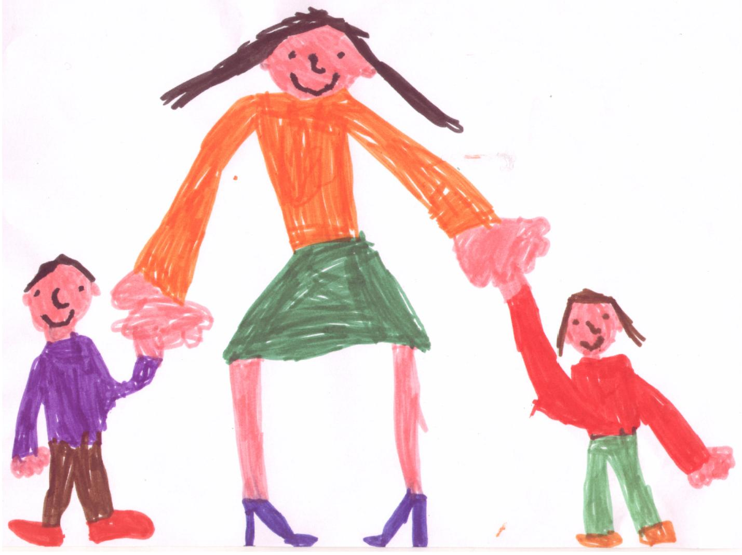It is important that on the first day of school, 4-5 years-old children, which already attended the kindergarten, are introduced separately from their new schoolmates. In this way, teachers can devote them the attention that would be inevitably less due to the arrival of new mates. It is crucial that children at their first scholastic experience are welcomed gradually, in small groups and for only morning hours. A period of time that will be gradually increased after arrangements with families.

Parents, after having spent some time with their children in the classroom, will leave them to come back at the decided time as this favors the sense of not being abandoned.

During the first scholastic week, it would be better to introduce newcomers only during game moments, avoiding the lunch breaks in order to make them gradually used to this particular moment.

The full day attendance of 3 years old children, with the afternoon rest, would only be possible after the fourth week, if the child will be ready to take this step, in arrangement with families.

A TYPICAL SCHOOL DAY

The school is open from September to June, following the school calendar of Lombardy Region. The annual calendar is deliberated by the School Council and will be handed to parents at the beginning of the scholastic year.

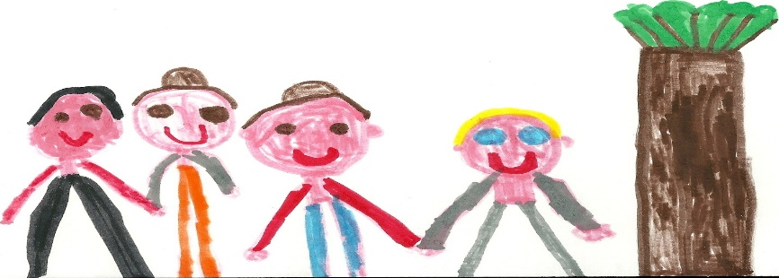

For the first week, the school is open only in the morning shift (8.30 – 13.30), as planned by the reception project.

Our school is open from Monday to Friday, from 8.30 to 16.30.

Our typical school day is organized as follows.

* 8,30-9,15: parents bring their child in the classroom, free play
* 9,15-10,15: tidying up, attendance record, calendar, circle time, toilet
* 10,15-10,30: fruit break in the school cafeteria
* 10,45-12: didactic activities with both teachers
* 12,00-13,00: lunch break
* 13,30-15,45: sleeping-time for the younger students
* 13,00-14,00: free play for mid and elder students
* 14,00-15,45: didactic activities for mid and elder students
* 15,45-16,10: tidying up, toilet, exit preparation
* 16,10- 16,30: the child wait the parent to come in the classroom and collect him/her

The school day is organized according to children's times and rhythms: spontaneous play moments are followed by practical life situations and they experience the approach to the socio-cultural reality (ex. Experiencing the body, others, words, nature…) in an environment characterized by games and exploration.

During the day, there are plenty of cognitive and socio-emotional stimuli, defined by teachers through didactic programming.

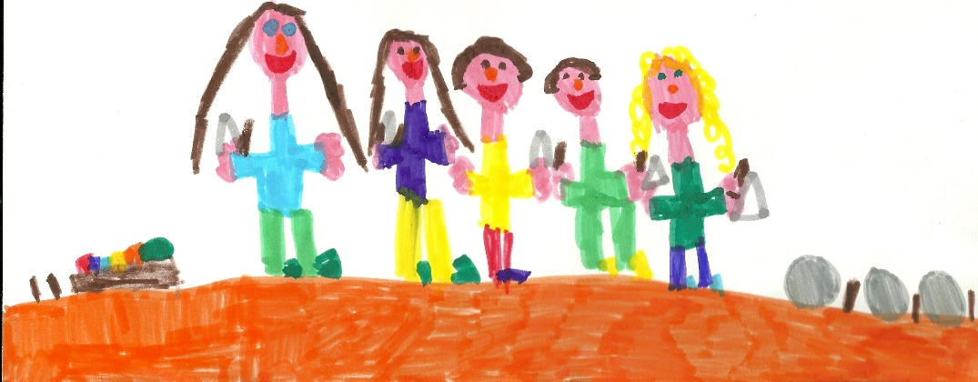

SOME CLARIFICATIONS:

* The respect of entry (8.30 – 9.15) and exit (16.10 – 16.30) times by parents represents a fundamental condition for a peaceful and effective undergoing of the scheduled activities, apart from being a form of necessary respect and collaboration.
* Early leaves for familiar needs can be allowed only between 13.10 and 13.30.
* The child can be taken from school only by his/her mother and father or by a person not younger than 18, with a written delegation signed by parents. Moreover, we want to remind that an adult at the entrance must accompany the child.
* Remind that it is not allowed to stay in the school buildings and courtyards after the closing time.
* The parent that wants to use the Pre-school (7.30-8.30) and/or the Post-school (16.30-18.00) services must register the child into the association “Le gru di Sadako” which manages these services in our school.

FOOD

The consumption of food has the educational value of growing-up toward personal independence and to the structuring of more comprehensive eating habits.

The menu is specifically designed following the dietary legislation and controlled in its quality, quantity and in the preparation modalities of meals by ASL experts.

A special “**Mensa Commission”**, composed by parents’, teachers’ and municipal administration representatives, constantly monitors the problems related to the proper running of this service.

Since the consummation of the meal is aimed at not only the feeding itself, but more to a gradual education towards correct food habits, the family can ask to the Comune, which is in- charge of the service, to modify the scholastic menu only for:

* allergies or food intolerances testified by a medical certificate previously handed to the ASL which can create a personalized diet.
* for muslims or vegetarians by filling the proper module

The request for a diet of plain food must by NORM provided by the Pediatrician and the Medico di Base, who will produce a certificate that must be handed over to the school which will deal with it in the records.

The diet of plain food could be requested in written form and only for 2 days, even from a parent in case of a serious event.

The cost of the meal and its payment modalities are established by the Comune.

ASSENZE, MALATTIE E RITIRI

* The Regional Law n.12 - 04.10.2003 abolishes in our Region the need of a medical certificate of re-admission after 5 days of absence. Hence, all the absences, of one or more days, both for health and family issues, must be justified by a written communication or directly to the teacher.
* In case of illness or fever of a student, teachers will advise parents on the further action that could be undertaken.
* The child, with evident stiches or casts can attend the school only with a medical certificate that proves the child suitability of attending school. The suitability is necessary to avoid further damages to the injured student and to/from other children.
* The child who has been vaccinated must be monitored at home for at least 24 hours.
* It is important to signal to the school the presence of lice to allow teachers to activate the envisaged prevention measures. On day after the start of the treatment, the child can return to school. When the School Director or on of his/her delegates indicates to the family possible symptoms which can be related to lice’s presence, at the re-admission, a declaration of having undertaken the envisaged actions must be provided (circular n.189 17/03/2009).
* The child who is absent from school without a written and justified permit/excuse for more than 30 days is cancelled by the lists of registered students.
* The child can be absent from school for family reasons, with a written and justified excuse, for a period of maximum 45 days, after that is cancelled by the lists of registered students.

OUTFIT/EQUIPMENT

Do you know that even a child needs an outfit?

1. Towel with ribbon
2. Bib with elastic
3. Apron for painting
4. Paper tissues, a photo of the child and an ID photo
5. A plastic glass (as required by classroom teachers)
6. A complete change of dresses (you never know!)
7. A light blanket, pillow, fitted sheet (for 3 years-old children)

Name and surname must be written on every piece otherwise we would spend entire days trying to recognize everyone’s stuff!

Remember that in the kindergarten we must have a functional outfit/equipment to allow the child autonomy. We need comfortable, practicable and easy to use stuff: we must play.

PARTICIPATION

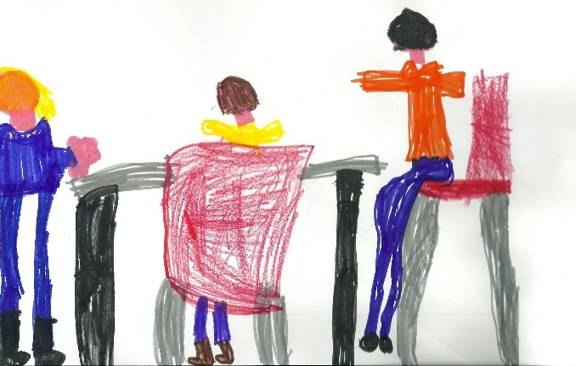

The following bodies implement the participation to the educational project:

1. Classroom Assembly
2. Inter-classroom Council
3. Institute Council

CLASSROOM ASSEMBLY

This is the moment when parents meet the teaching staff to receive information about the school educational project and its daily implementation and to make proposals.

In this moment parents can figure out how their children react to the school stimuli.

We invite you to always participate to the meetings! We talk about your children, is there something or someone more important than them?

For us children, however, is advisable not to be present as we could not be free to play and move and you to speak.

INTER-CLASSROOM COUNCIL

It reunites all the elected parents’ classroom representatives and teachers.

It deals with educational, organizational and logistics problems.

INSTITUTE COUNCIL

Composed by:

1. Parents’ representatives elected in the kindergarten, the primary school and in the first level secondary school.
2. Elected teachers of kindergarten, primary and first level secondary school
3. Scholastic and administrative co-workers
4. School Director

They discuss organizational, financial and logistical issues, related to the school of the Comprehensive Institute.

THE STAFF

TEACHING STAFF

Each classroom has two teachers who alternate each other during the day. Some hours, usually the most central of the morning, both teachers are present; in this way, it is possible to organize small groups for more individualized didactic activities.

If in the classroom there are kids with special needs/differently abled a sustain teacher and/or an educator is/are provided.

The catholic religion teacher will have one hour and a half lesson each week in every classroom.

An institute teacher (contact person) has the task of coordinating between school operators, parents, and the Management.

SCHOOL CO-WORKERS

In every school, there are co-workers who are responsible of cleaning, building surveillance, assistance, reproduction of informative and didactic material.

DIRECTION BOARD

The School Director has the tasks of coordination, promotion, examination and evaluation of teachers, parents and scholastic co-workers, about the whole running of the school educational service.

ADIMINSTRATIVE STAFF

The opening hours of the administration in the Primary School of Terno d’Isola are the following ones:

|  |  |
| --- | --- |
| * Monday and Wednesday | from 14.00 to 16.00 |
| * Tuesday, Thursday and Friday | from 10.30 to 13.30 |
| * Saturday | from 8.30 to 11.30 |

During the suspension of didactic activities: from 9 to 12 every day excluding Saturday and holidays.

RELEVANT CONTACT DETAILS!

**COMPREHENSIVE STATAL SCHOOL**

“Padre Cesare Albisetti”

24030 – Terno d’Isola (BG) Via dei Vignali 19 –

Tel 035.4940048

Fax 0354949672

Website: [www.icternodisola.gov.it](http://www.icternodisola.gov.it)

E-mail: bgic88100d@istruzione.it

icterno@libero.it

**KINDERGARTEN TERNO D’ISOLA**

Via dei Vignali, 19

**Tel. 0354940982**

**COMUNE DI TERNO D’ISOLA**

Via Casolini

Tel. 0354940001

Traduzione realizzata con il Progetto FAMI LAB'IMPACT

[www.aziendaisola.it](http://www.aziendaisola.it) Azienda Isola

e pagina Facebook Labimpact ambito Isola Bergamasca